Important dates:  16th Nov: Phonics Workshop 3.30pm  12th Dec: Christmas Performance 1pm  13th Dec: Christmas Performance 1pm  14th Dec: Cinderella at The Maltings  21st Dec: Carol Service at Tweedmouth Parish Church  22nd Dec: Break up for school holidays | Autumn 2 2023  Learning overview  Year 2  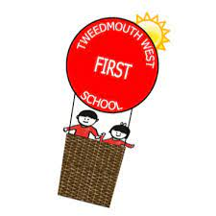 | Geography: Enquiry  Why do penguins not need to fly?  - Continents, focusing on Antarctica  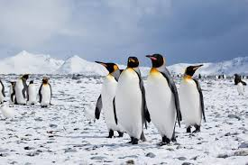  - Deserts  - Food chains  - Adaptation | Science  Animals including humans:  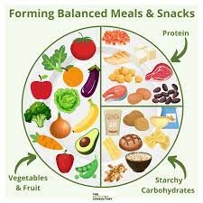  - Exercise and how it affects our bodies  - Healthy diet  - Keeping clean  - Keeping warm
Reading:  - Building fluency  - Comprehension skills  - Reading for pleasure (library books, books from home)  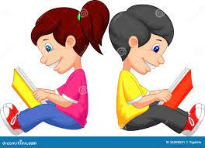 | Writing:  - Stamina for writing  - Imaginative stories  - Picture prompts  - Poetry  Grammar:  - Correct use of capital letters and full stops  - Adjectives (noun phrases)  - Conjunctions (and, so, but, because, therefore etc) | Speaking and listening:  - Oracy – Voice 21 project (more details to follow)  - Giving reasons for their answers  - Discussions  - Opinions  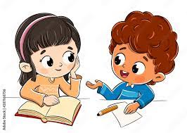 | Maths: Numbers to 100  - Adding 3 single digits  - Addition on number lines  - Adding 2 numbers that bridge the 10’s boundary  - Subtracting 2 numbers hat bridge the ten boundary  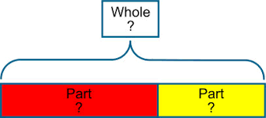  - Addition and subtraction involving bar models
Computing  - Online self-image and identity  - Research using the internet | 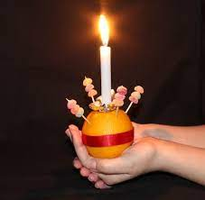  Religious Education  Incarnation:  - Why does Christmas matter to  Christians?  - Christingle  - Nativity |  | 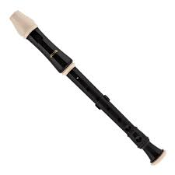  Music:  - Singing  - Playing recorders  - Recognising ‘beat’  - Music appreciation
PE:  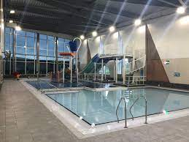  Gymnastics on a Tuesday  Swimming on a Wednesday | RSHE: My Healthy Body  - Eating a balanced diet  - Exercise  - Keeping clean  - Sleep | Design and Technology:  - Making simple toys from paper  - Exploring how to improve the paper toys  - Evaluating their creations against design criteria | Homework:  - Reading book every night  - Weekly spelling lists  - KIRF’s

