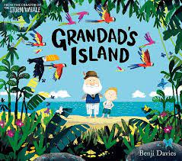
Maths  Mastering Number  Comparison of quantities and part-whole relationships  Numbers 0-5  Recognise, compose, decompose and manipulate 2D and 3D shapes | Reading  - Daily Read Write Inc phonics sessions  - Actions words  - Year 1 common exception words  - Read words accurately by blending unfamiliar words | Writing  Grandad’s Island  - Capital letters  - Spaces in between words  - Full stops  - Adjectives  - Re-read writing to check that it makes sense  - Saying out loud what they are going to write | 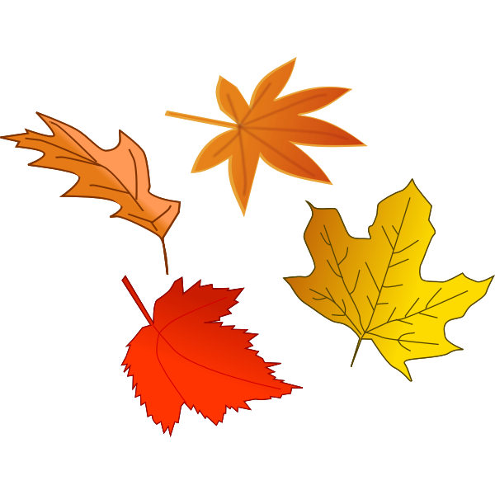  Science  Animals including humans  - Name  - Label  - Draw  - Link the 5 senses to the body part
Humanities  Why is the history of my locality important?  - Seaside Magic  - Spittal  - The Dock  - Trip  - Making comparisons | Autumn 2 2023  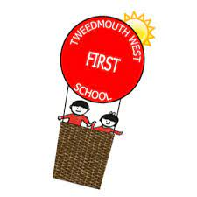  Learning overview  Year 1 | Speaking and listening  - Role play  - Collaborative discussion  - Articulate and justify answers  - Participate in class discussion  - To share ideas | Religious Education  Why does Christmas matter to Chrisians?  - Baby Jesus  - The Christmas story
Computing  - Project Evolve  - Self Image and Identity  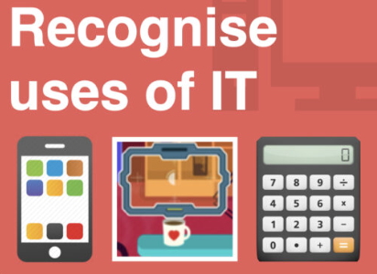  - Recognise the use of IT | Important dates:  Thurs 16th Nov Phonics Workshop  Fri 17th Nov Children in Need - Own clothes day  Tues 28th Nov Local walk to the Dock  Tues 12th Dec Whole School Fireside Nativity  Wed 13th Dec Whole School Fireside Nativity  Thur 14th Dec Whole School Panto trip Maltings  Wed 20th Dec Christmas Dinner Day  Thurs 21st Dec Carol Service  Fri 22nd Dec Break up for Christmas at 2pm | DT  Moving christmas card  - Designing  - Making a working slider  - Painting  - Evaluating | Music  Dance, Sing and Play!  - Singing  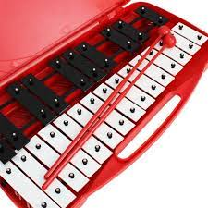  - Playing the glockenspiel  - Improvisation  - Clapping rhythms
PE  Gymnastics  - Balance  - Coordination |  | PSHE  Keeping safe and managing risk | Homework  Reading book  Library book  Spellings  KIRFs

