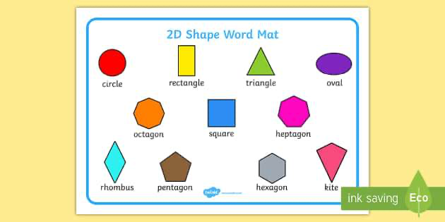
Maths  NCETM  2D and 3D shape  - Copy  - Compose  - Investigate  - Identify  Numbers 0-10  - Counting  - Using the five and a bit structure  - Part whole model  - Odd and even numbers  - Partition a number | Reading  Daily Read Write Inc phonics session  Reading for pleasure - library book, class story each day and reading books | Writing  The Comet - Joe Todd-Stanton  - Posters  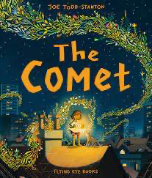  - Letters of advice  - Poem  - Description  - Writing in role  - Recipes | 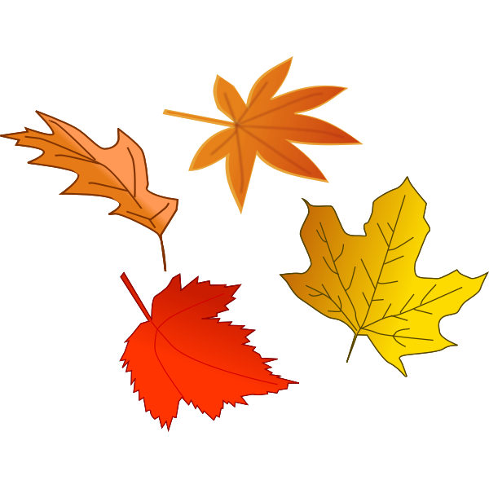  Science  Everyday materials  - Naming materials  - Learning about materials and their properties  - Testing materials and their properties  - Investigating  - Sorting
 | Homework  Reading book every night  Weekly spellings on seesaw  KIRFs | PSHE  Identity, society and equality  Me and others
Geography  Our school, where do we live?  - Basic geographical features - human and physical  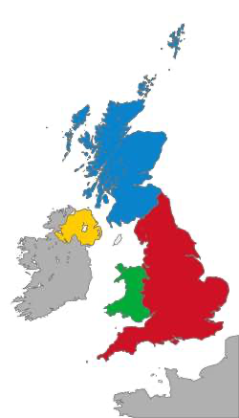  - Major cities in the UK  - 4 nations within  the UK  - Land use zones of  our local area | Spring 1 2023  Learning overview  Year 1 | Speaking and listening: Oracy Framework  - Use topical language correctly  - Listen to others  - Join in with class discussion  - Speak loudly and clearly in class discussions | 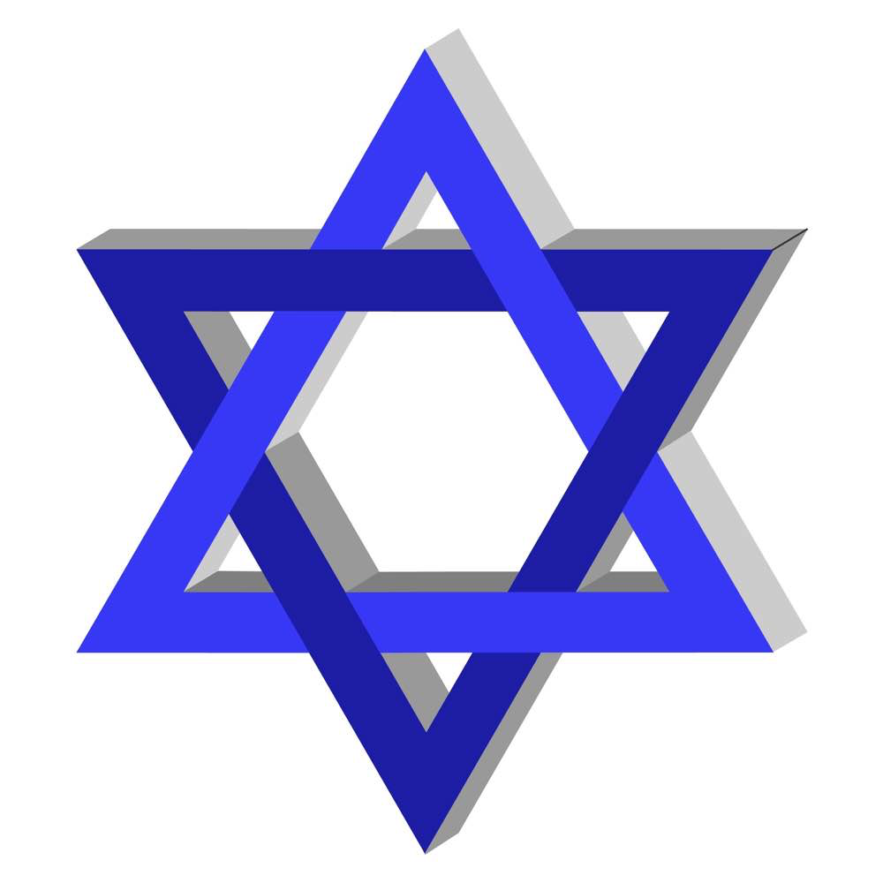  Religious Education  Judaism  Who is Jewish and how do they live?  - Main beliefs  - Places that are special  - Jewish festivals  - Jewish symbols
DT
Our Fabric Faces
- Making hair
- Joining
- Face shapes
- Designing our fabric face
- Making our fabric face
PE  Apparatus - Monday afternoon  Skills for life - creative  Co Jo - Thursday afternoon |  | Important dates:  Wed 17th Jan - Open Evening 4-5  Fri 16th Feb - Last day of the half term 3:15pm | Music  Exploring sounds  - Play the glockenspiel  - Sing  - Improvise  - Compose

