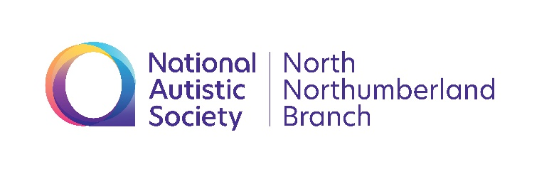
North Northumberland Branch
National Autistic Society

Autism training workshops with
Deborah Garland, trainer consultant.

January 15th Understanding Autism
February 5th Sensory Needs
March 25th Supporting Stress and Anxiety Related Behaviour

At Chatton Village Hall, Old Road, Chatton, Alnwick, NE66 5PX
10am – 12 noon with lunch afterwards
These are free events, please book, stating which workshop(s) for numbers.
Contact Helen Sutherland for more information
northnorthumberland.branch@nas.org.uk
facebook NAS north northumberland branch

