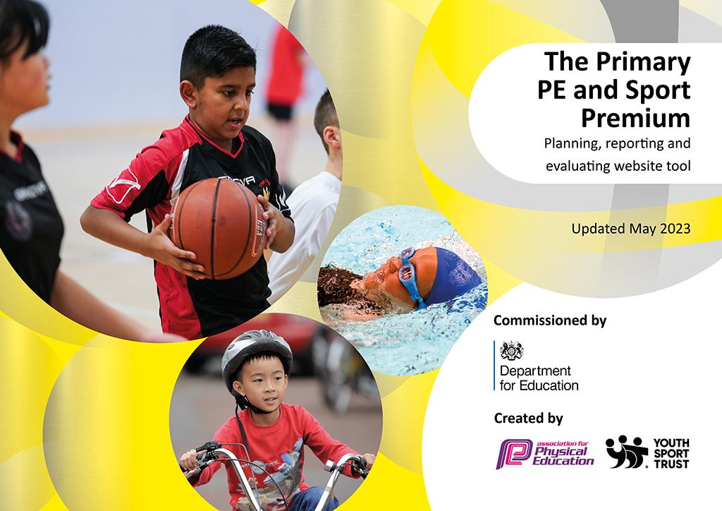
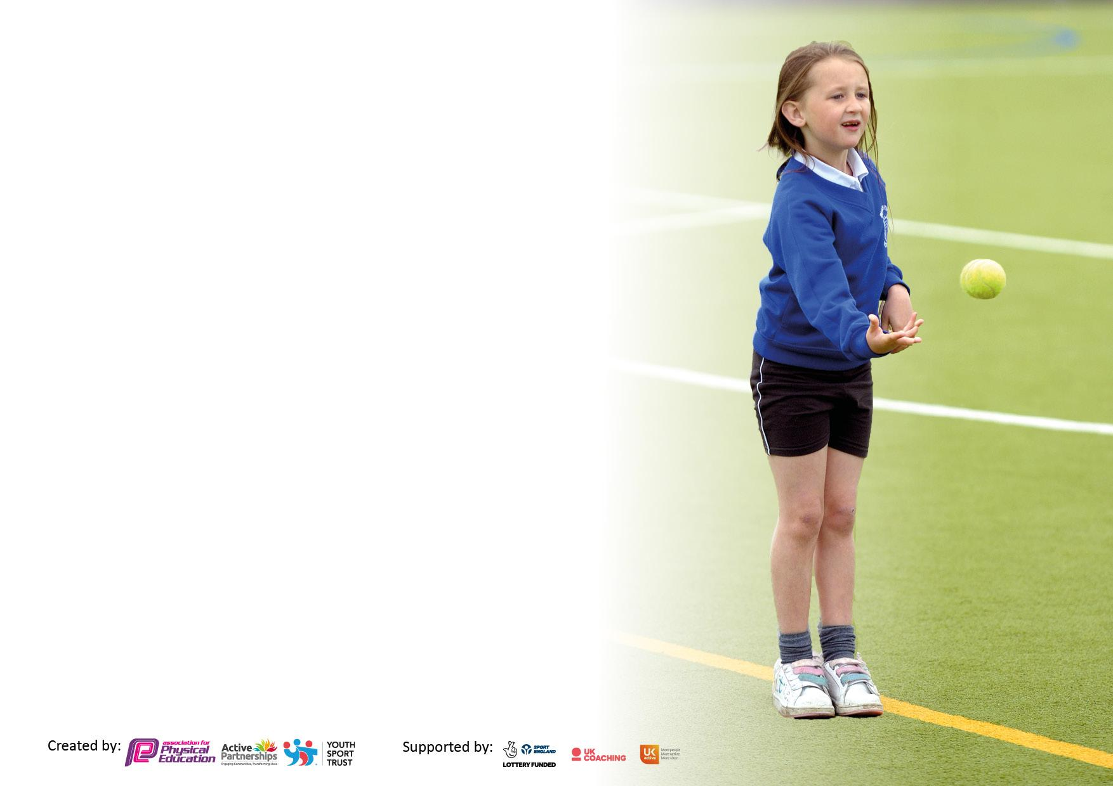

It is important that your grant is used effectively and based on school need. The Education Inspection Framework makes clear there will be a focus on ‘whether leaders and those responsible for governors all understand their respective roles and perform these in a way that enhances the effectiveness of the school’.

Under the Quality of Education Ofsted inspectors consider:
Intent - Curriculum design, coverage and appropriateness
Implementation - Curriculum delivery, Teaching (pedagogy) and Assessment
Impact - Attainment and progress

To assist schools with common transferable language this template has been developed to utilise the same three headings which should make your plans easily transferable between working documents.

Schools must use the funding to make additional and sustainable improvements to the quality of Physical Education, School Sport and Physical Activity (PESSPA) they offer. This means that you should use the Primary PE and sport premium to:

- Develop or add to the PESSPA activities that your school already offer
- Build capacity and capability within the school to ensure that improvements made now will benefit pupils joining the school in future years
- The Primary PE and sport premium should not be used to fund capital spend projects; the school’s budget should fund these.

Pleasevisitgov.ukfortherevisedDfEguidanceincludingthe5keyindicatorsacrosswhichschoolsshoulddemonstrate animprovement.Thisdocumentwillhelpyoutoreviewyourprovisionandtoreportyourspend.DfEencouragesschools to use this template as an effective way of meeting the reporting requirements of the Primary PE and Sport Premium.

We recommend you start by reflecting on the impact of current provision and reviewing the previous spend.

Schools are required to publish details of how they spend this funding, including any under-spend from 2021/2022, as well as on the impact it has on pupils’ PE and sport participation and attainment. All funding must be spent by 31st July 2023.

We recommend regularly updating the table and publishing it on your website throughout the year. This evidences your ongoing self-evaluation of how you are using the funding to secure maximum, sustainable impact. Final copy must be posted on your website by the end of the academic year and no later than the 31st July 2023. To see an example of how to complete the table please click HERE.
Details with regard to funding
Please complete the table below.

Total amount carried over from 2021/22 | £Nil
Total amount allocated for 2021/22 | £16,990
How much (if any) do you intend to carry over from this total fund into 2022/23? | £ Nil
Total amount allocated for 2022/23 | £16,960
Total amount of funding for 2023/23. To be spent and reported on by 31st July 2023. | £ 16,960
Swimming Data
Please report on your Swimming Data below.

Meeting national curriculum requirements for swimming and water safety.  N.B. Complete this section to your best ability. For example you might have practised safe self-rescue techniques on dry land which you can then transfer to the pool when school swimming restarts.  Due to exceptional circumstances priority should be given to ensuring that pupils can perform safe self rescue even if they do not fully meet the first two requirements of the NC programme of study | NA
What percentage of your current Year 6 cohort swim competently, confidently and proficiently over a distance of at least 25 metres?  N.B. Even though your pupils may swim in another year please report on their attainment on leaving primary school at the end of the summer term 2022.  Please see note above | %NA
What percentage of your current Year 6 cohort use a range of strokes effectively [for example, front crawl, backstroke and breaststroke]?  Please see note above | %NA
What percentage of your current Year 6 cohort perform safe self-rescue in different water-based situations? | %NA
Schools can choose to use the Primary PE and sport premium to provide additional provision for swimming but this must be for activity over and above the national curriculum requirements. Have you used it in this way? | No

Action Plan and Budget Tracking
Capture your intended annual spend against the 5 key indicators. Clarify the success criteria and evidence of impact that you intend to measure to evaluate for pupils today and for the future.

Academic Year: 2022/23 | Total fund allocated:£16,960 | Date Updated: 7th July 2023
Key indicator 1: The engagement of all pupils in regular physical activity – Chief Medical Officers guidelines recommend that primary school pupils undertake at least 30 minutes of physical activity a day in school |  |  |  | Percentage of total allocation:
 |  |  |  | %
Intent | Implementation |  | Impact
Your school focus should be clear what you want the pupils to know and be able to do and about  what they need to learn and to  consolidate through practice: | Make sure your actions to achieve are linked to your intentions: | Funding allocated: | Evidence of impact: what do pupils now know and what can they now do? What has changed?: | Sustainability and suggested next steps:
It is our intention when teaching the PE curriculum we develop the enjoyment of physical activity and strive to improve the importance of health and well-being. It is our intention to engage all pupils at Tweedmouth West in the possibilities of sport to develop a passion for being active, healthy and have the confidence to try new things. We aim to build resilience and determination in all that they do with us and in their future as they move on in their lives.  Our involvement with the School Games gives us a perfect opportunity to put physical activity and competitive sport at the heart of our school, it provides our children with more opportunity to compete and achieve their personal best.  The school has a clear vision of progression throughout the school due to the fact our PE Coordinator teaches PE across all key stages and is involved with all of the assessment and differentiation | Informed all staff and children of the Chief Medical Officers guidlines - recommendation 30 minutes of physical activity a day in school.  Where possible lessons include physically active learning in order to engage children in higher levels of Physical Activity throughout the school day; eg Active Maths & Active Literacy.  Provided equipment to promote physical activity throughout the day (lessons, break times and After school provision).  Increased physical activity at break and lunchtimes.  Year 4 leadership training (by School sports partnership).  Physical activity is an integral part of learning through play sessions (Early Years) helping pupils achieve their early learning goals.  Promoted the benefits of the daily mile and encouraged staff and pupils to take part.  Commando Joe Programme delivered a respect curriculum alongside physical activity | £1475.00(COJO)  £3500.00 (NU Foundation)  £1092.32  (Playgroup equipment and Boogie Box )  £22322.68 (Early Years balance and sensory equipment) | Staff are aware of the 30 minute GOV advise.  Each class receives 2 hours of timetabled PE per week.  Active lessons as well as active breaks are planned into their day.  Children are self motivated to improve their physical health and skills at break times (observation)  Children are able to use equipment safely and take responsibility to look after it.  Children are now more equipped to show respect, be resilient and take on more responsibility.  All year 4 pupils had a leadership role in KS1 sports day.  95% of children in key stage 2 have attended an after school sports club. | Promote benefits of the daily mile to improve fitness and well being of both staff and pupils.  Encourage lunchtime staff to promote active play.  Continue with Nu provision.  Attend festivals and competitions offered from School sports partnership.  PE leads to be involved with provision to competition from NU foundation.
Key indicator 2: The profile of PESSPA being raised across the school as a tool for whole school improvement |  |  |  | Percentage of total allocation:
 |  |  |  | %
Intent | Implementation |  | Impact
Your school focus should be clear what you want the pupils to know and be able to do and about  what they need to learn and to  consolidate through practice: | Make sure your actions to achieve are linked to your intentions: | Funding allocated: | Evidence of impact: what do pupils now know and what can they now do? What has changed?: | Sustainability and suggested next steps:
To continue to raise the profile of school sport and physical activity. To share our mission with school & partnership staff as well as parents and pupils; We embed and enable the children to make informed choices about physical activity throughout their lives. | Provided PE training to all staff (shadowed NU staff)  Shared our PE policy/mission on our website.  Celebrate personal best achievement in lessons, assemblies and websites.  Celebrate achievement through displays, on websites, newsletters, local press etc.  Promoted and encouraged children to attend after school sports clubs.  Promoted local sports clubs and encouraged children to attend. | £3500  (NU foundation) | Staff are now more confident to promote and deliver physical activity.  95% of KS2 children attended an after school sports club.  Children have the confidence to attend local sports clubs. | Subscribe to the AFPE membership to support teachers with their planning of PE sessions.  Complete a staff survey to ensure staff are getting the support that they need to deliver PE and provide them with any extra resources that they need.  Provide Governor Training to ensure they have an understanding of our intent and how our PE spend helps us to achieve this.

Key indicator 3: Increased confidence, knowledge and skills of all staff in teaching PE and sport |  |  |  | Percentage of total allocation:
 |  |  |  | %
Intent | Implementation |  | Impact
Your school focus should be clear | Make sure your actions to | Funding | Evidence of impact: what do | Sustainability and suggested
what you want the pupils to know | achieve are linked to your | allocated: | pupils now know and what | next steps:
and be able to do and about | intentions: |  | can they now do? What has
what they need to learn and to |  |  | changed?:
consolidate through practice:
To ensure High quality PE teaching and learning across the school. Teachers to increase their subject knowledge and confidence | Teachers shadowed NU foundation staff and specialists to upskill their knowledge and skills.  Teachers have a better understanding of the fundamentals of PE and be more confident in delivery of physical education. | £3500  (NU Foundation) | The sports coaches/teachers of NU foundation are key members of Tweedmouth West first school team. They work alongside class teachers to provide outstanding PE sessions. Skills, knowledge and understanding of pupils and staff have increased - Through assessment, children and staff have a good awareness of levels of competence and how to improve. | Dedicate at least one staff meeting for training per term  Lesson Observations
Key indicator 4: Broader experience of a range of sports and activities offered to all pupils |  |  |  | Percentage of total allocation:
Intent | Implementation |  | Impact
Your school focus should be clear | Make sure your actions to | Funding | Evidence of impact: what do | Sustainability and suggested
what you want the pupils to know | achieve are linked to your | allocated: | pupils now know and what | next steps:
and be able to do and about | intentions: |  | can they now do? What has
what they need to learn and to |  |  | changed?:
consolidate through practice:
It is our intention to engage all pupils at Tweedmouth West in the possibilities of sport to develop a passion for being active, healthy and have the confidence to try new things. We aim to build resilience and determination in all that they do with us and in their future as they move on in their lives.  It is our intention to provide all children with the fundamental skills to take part in a broad range of sport and give children the opportunity through lessons and extracurricular a wide range of activities/sports. We will Provide opportunities to inspire pupils to achieve their ‘personal best' and encourage them to participate in extra- curricular activities and local clubs.  Additional achievements: | Provided a broad range of after school clubs to KS2. Promoted local sports clubs/sessions to parents and children.  Outside agencies have provided children with;  - Bikeability (whole school)  - Hoopstarz (whole school)  - Skip school (Year 4)  - Boogie Beats (Reception)  - Yogi Bairns (Year 1)  - Fundamental dance (reception & year 1) | £500.00  (skipping)  £330.00 (Dance)  £330.00 (Hoopstarz)  £300.00 (Yogi Bairns)  £200.00 (Boogie Beats) | All children are more resilient and can achieve their personal best.  95% KS2 attended after school clubs  40% KS2 children attend local sports clubs.  21 Year 4 children achieved their level 1 Bikeability  All year 2 & 3 children can ride a bike without stabilizers.  All year 4 children can skip | Continue our provision from NU foundation  Continue or engagement with School Games Officer

Key indicator 5: Increased participation in competitive sport |  |  |  | Percentage of total allocation:
 |  |  |  | %
Intent | Implementation |  | Impact
Your school focus should be clear | Make sure your actions to | Funding | Evidence of impact: what do | Sustainability and suggested
what you want the pupils to know | achieve are linked to your | allocated: | pupils now know and what | next steps:
and be able to do and about | intentions: |  | can they now do? What has
what they need to learn and to |  |  | changed?:
consolidate through practice:
Our intention is to offer a variety of competition;  Personal best  Festival  Intra school  Inter school | Plan competition into lessons. Yearly competition timetable included festivals, intra and inter competitions.  Festivals and Competition;  - Attended Berwick Area School Games Gymnastics Competition  - Attended Berwick Area School Games Quad Kids Competition  - Attended Dodgeball transition event at Tweedmouth Middle School  - Attended Learn to bowl lead by Berwick Academy Sports Leaders Attended School  - Attended Skip School festival  - School Games Multiskills (Virtual Competition)  - Berwick Area Chance to Shine Cricket Festival | £ NIL | All children have an understanding of how to achieve their own personal best.  All children have taken part in intra school competitions.  All KS2 children have been given the opportunity to attend a sports festival and the opportunity to ‘aim higher’  Children aspire to represent Tweedmouth West in competition.  School Games Gymnastics Competition (2 teams) - Berwick Area winners and runners up  Two teams represented North Northumberland at the Gymnastics County finals  School Games Quad Kids Competition - Berwick Area Winners  Quad Kids represented North Northumberland at the county finals and came runners up. | Plan intra school competition calendar with NU foundation  Staff at the end of each unit being taught.  Plan inter school competition timetable with SGO and NU foundation manager.

Signed off by
Head Teacher:
Date:
Subject Leader: | Julie Pick
Date: | 10th July 2023
Governor:
Date:

